LAB 06

Python for and while Loops

- Basic Task: Write a for loop to print the first 10 natural numbers.
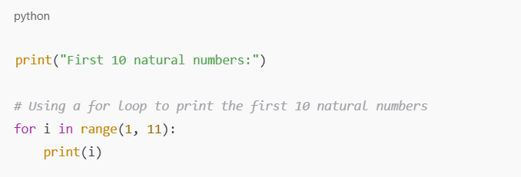
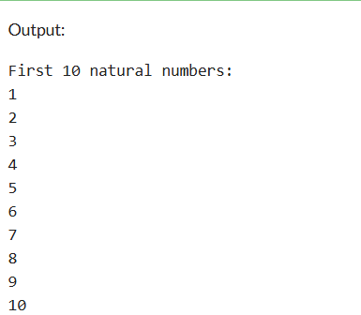

- Intermediate Task: Write a while loop that prints numbers from 10 down to 1.
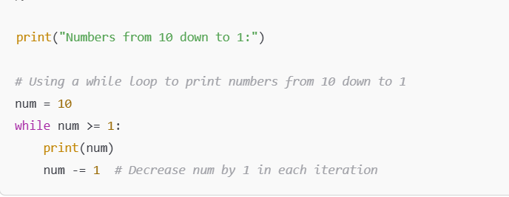
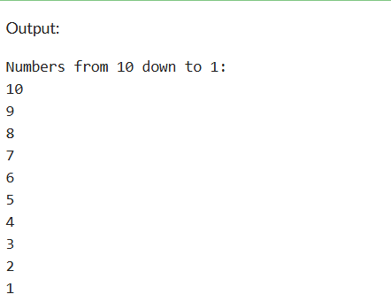
- Advanced Task: Create a program that uses a for loop to iterate over a string and count the number of vowels.
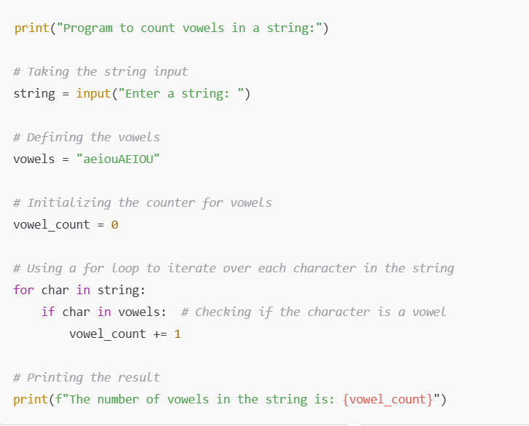
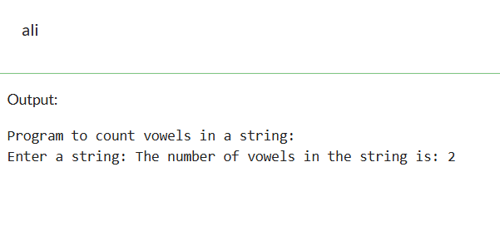

- Challenge Task: Write a program that prints the Fibonacci series up to n terms using a while loop.
